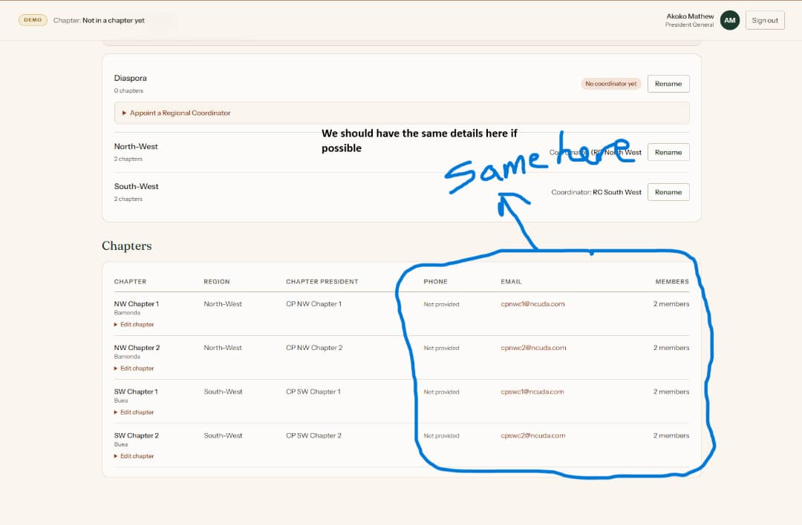
Figure 1 The Regional coordinators number, email and the number of members in a region should be shown here just as the chapter president’s own are
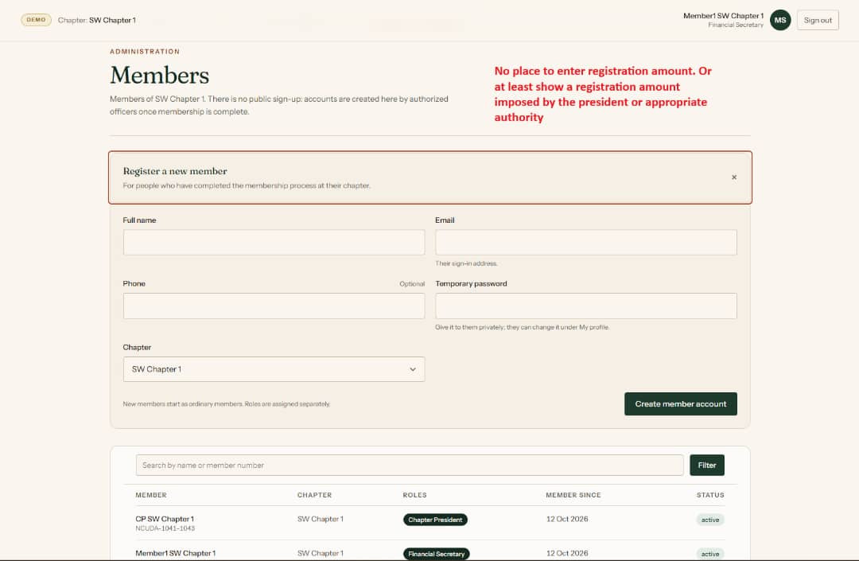
Figure 2 When registering members there should be a place to input the registration amount. This amount is the same for all new members so no executive and ordinary member distinction should be made at this point
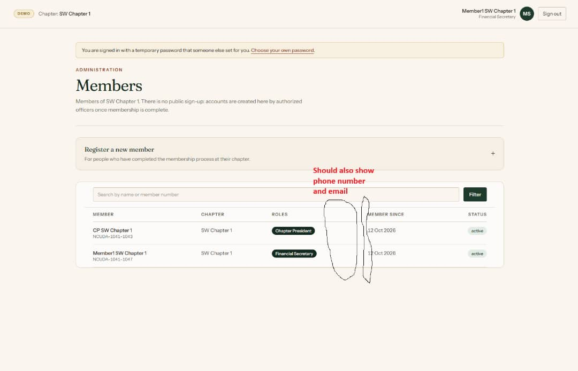
Figure 3 This table should include their email and phone number
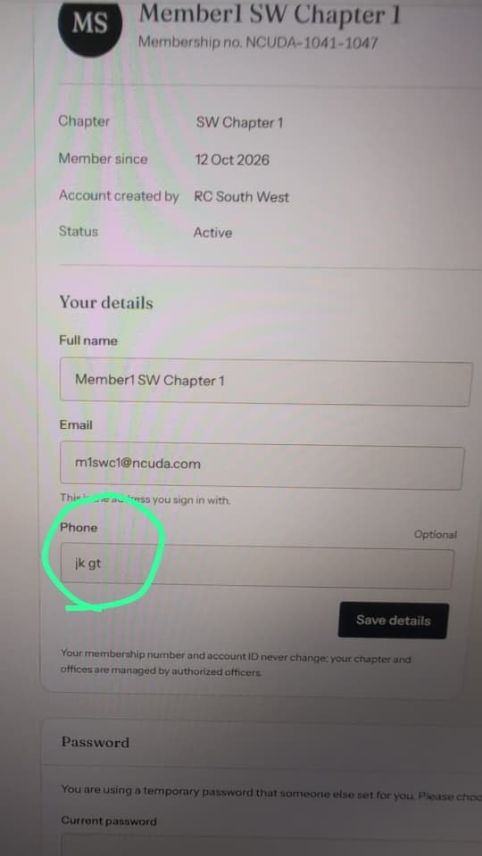
Figure 4 Phone number fields should not accept letters. It could accept +

